**CSA1518 – CLOUD COMPUTING & BIG DATA ANALYTICS FOR SOCIAL MEDIA**

**G SHIYAM SUNDHAR**

(**191911582L**)

**EXP NO : 06 & 07**

***Demonstrate virtualization by Installing Type-2 Hypervisor in your device, create and configure VM image with a Host Operating System (Either Window/Linux).***

**Step 1:**

Click On - Create a New Virtual Machine

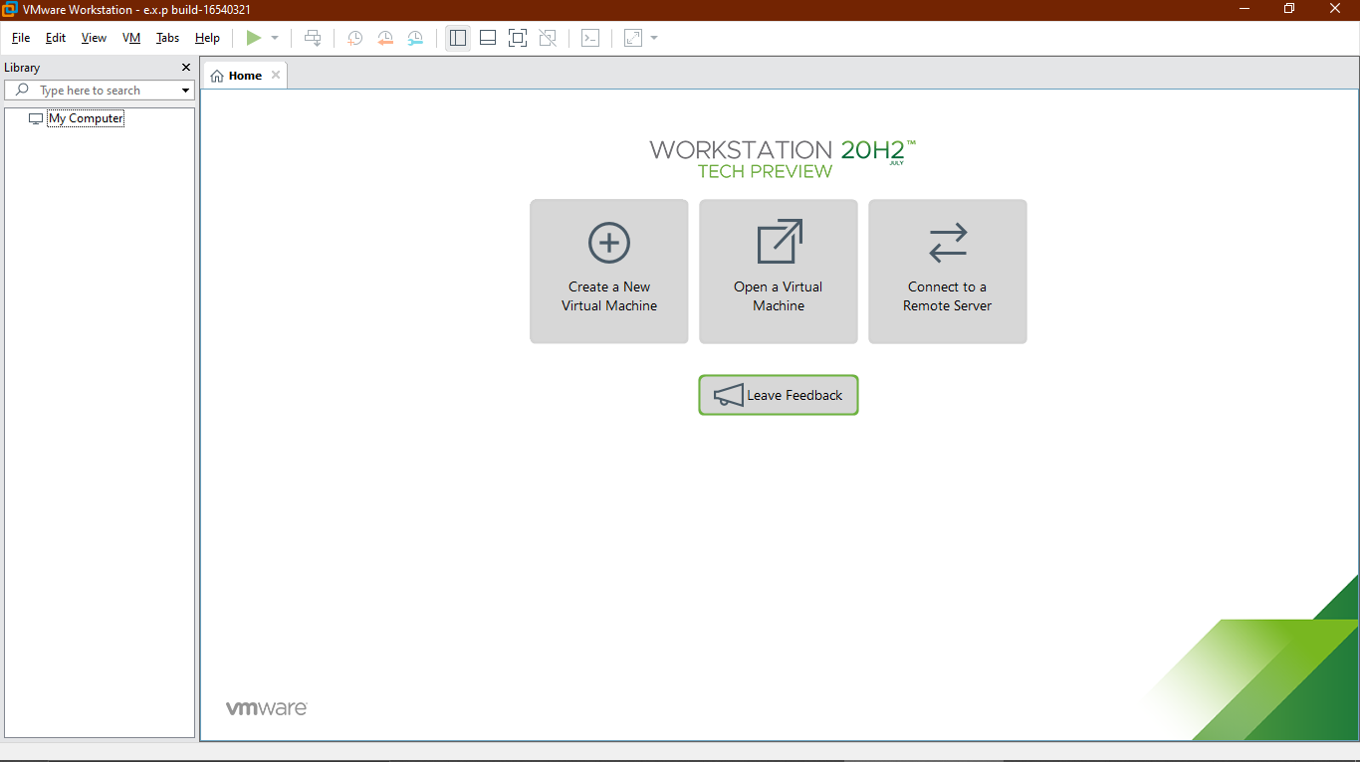

**Step 2:**

Click On – Typical (Recommended) and Click On NEXT.

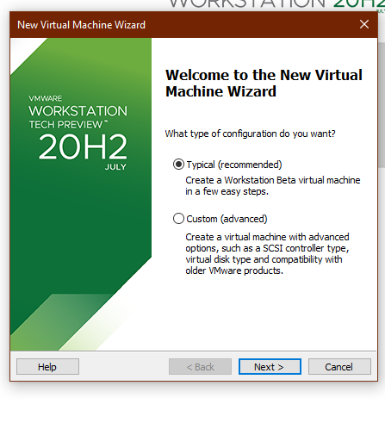

**Step 3:**

Click On – Installer disc image file (ISO) and Click On NEXT.

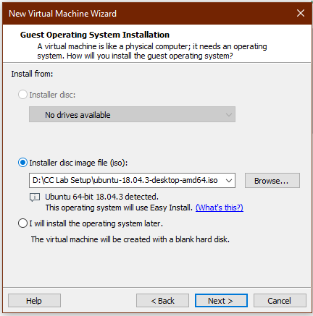

**Step 4;**

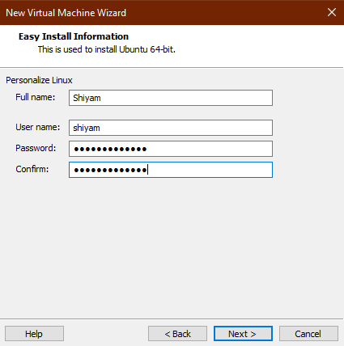

**Step 5:**

Select the Option – Linux for GUEST OPERATION SYSTEM and Version as Ubuntu 64bit.

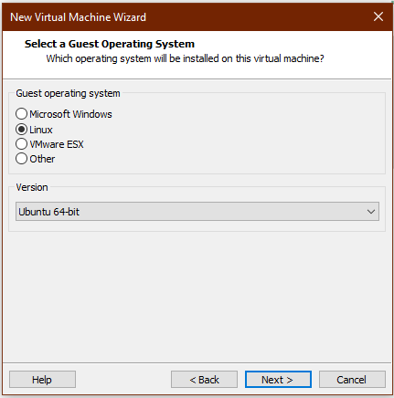

**Step 6:**

Specify the Disk Capacity and select “Store Virtual Disk as a Single File.

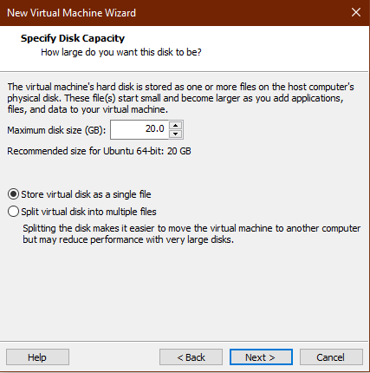

**Step 7:**

Click Finish

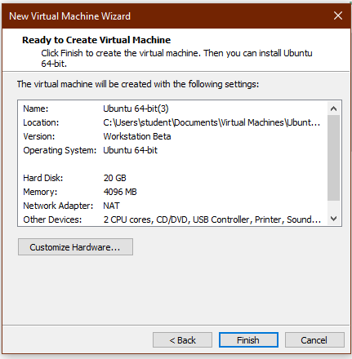

**Step 8:**

This is the Output frame where you need to run the program and verify the output the output through clicking POWER ON THIS VIRTUAL MACHINE option.

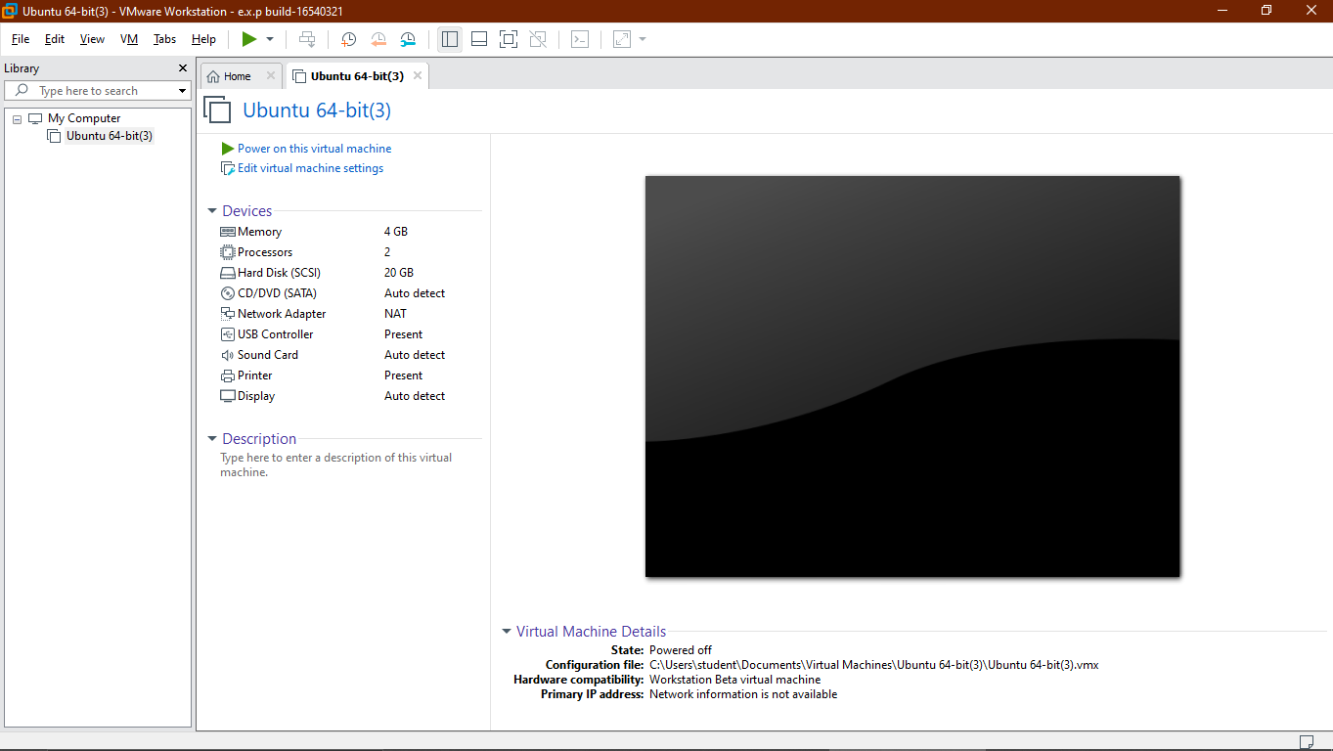

**Step 9:**

Ubuntu VM will be LOADED finally.

